**A Lab Manual**

**On**

**FULL STACK WEB DEVELOPMENT LAB**

**(III- B. Tech. – II– Semester)**

**Submitted to**

**DEPARTMENT OF COMPUTER SCIENCE & ENGINEERING**

**(DATA SCIENCE)**

**By**

**Ms. V.V.BHAVANI**

(Asst Professor, Dept. of CSE(DS)



**CMR INSTITUTE OF TECHNOLOGY**

Kandlakoya(V), Medchal Road, Hyderabad – 501 401

Ph. No. 08418-222042, 22106 Fax No. 08418-222106

**(2023-24)**

**CONTENTS**

| **Sl. No.** | **Particulars** | **Page No.** |
| --- | --- | --- |
|  | Vision and Mission | **2** |
|  | Syllabus | 4 |
|  | Student Entry Behavior or Pre-requisites | 5 |
|  | Course Outcomes | 6 |
|  | Mapping of Course with PEOs-POs | 7 |
|  | Mapping Of Course Outcomes with POs | 9 |
|  | Direct Course Assessment | 10 |
|  | Indirect Course Assessment | 11 |
|  | Overall Course Assessment and Attainment level | 13 |
|  | Pi diagrams, Bar charts, Histograms for representing results | 14 |
|  | Lesson/Course Plan | 15 |
|  | Programs | 16 |

**CMR INSTITUTE OF TECHNOLOGY**

**VISION:** To create world class technocrats for societal needs

**MISSION:** Impart global quality technical education for a better future by providing appropriate learning environment through continuous improvement and customization

**QUALITY POLICY:** Strive for global excellence in academics and research to the satisfaction of students and stakeholders

**DEPARTMENT OF COMPUTER SCIENCE AND ENGINEERING:**

**COMPUTER SCIENCE AND ENGINEERING (DATA SCIENCE)**

**Vision:**  To be a model for academic excellence and research in the field of computer science and engineering with a special focus on applications of Data Science that leads to innovative skills and moral values for the betterment of global society with professional concern.

**Mission:** Impart quality education through state-of-art curriculum by providing conducive learning & research environment for continuous improvement and professional advancement**.**

**I. PROGRAMME EDUCATIONAL OBJECTIVES (PEO’s)**

**PEO1:** Graduate will be capable of practicing principles of computer science & engineering, mathematics and scientific investigation to solve the problems that are appropriate to the discipline.[PO’s: 1,2,3,4,5,7,8,9,10,11 and 12] [PSO’s: 1and 2]

**PEO2:** Graduate will profess in Data Science applications that lead to professional, career and research advancement. [PO’s: 1,2,3,4,5,6,7,8,9,10 and 12] [PSO’s: 1, 2 and 3]

**PEO3:** Graduate exhibits professional ethics, communication skills, teamwork and adapts to changing environments of engineering and technology by engaging in lifelong learning. [PO’s: 1,2,3,4,5,6,7,8,9,10,11 and 12] [PSO’s: 2 and 3]

**II. PROGRAMME OUTCOMES (PO’s)**

1**.       Engineering knowledge**: Apply the knowledge of mathematics, science, engineering fundamentals, and an engineering specialization to the solution of complex engineering problems. **[PEO’s: 1,2 and 3]**

2.       **Problem analysis**: Identify, formulate, review research literature, and analyze complex engineering problems reaching substantiated conclusions using first principles of mathematics, natural sciences, and engineering sciences. **[PEO’s: 1,2 and 3]**

3.       **Design/development of solutions**: Design solutions for complex engineering problems and design system components or processes that meet the specified needs with appropriate consideration for the public health and safety, and the cultural, societal, and environmental considerations**. [PEO’s: 1,2 and 3]**

4.       **Conduct investigations of complex problems**: Use research-based knowledge and research methods including design of experiments, analysis and interpretation of data, and synthesis of the information to provide valid conclusions. **[PEO’s: 1,2 and 3]**

5.       **Modern tool usage**: Create, select, and apply appropriate techniques, resources, and modern engineering and IT tools including prediction and modeling to complex engineering activities with an understanding of the limitations. **[PEO’s: 1,2 and 3]**

6.       **The engineer and society:** Apply reasoning informed by the contextual knowledge to assess societal, health, safety, legal and cultural issues and the consequent responsibilities relevant to the professional engineering practice. **[PEO’s: 2 and 3]**

7.       **Environment and sustainability**: Understand the impact of the professional engineering solutions in societal and environmental contexts, and demonstrate the knowledge of, and need for sustainable development. **[PEO’s: 1,2 and 3]**

8.       **Ethics:** Apply ethical principles and commit to professional ethics and responsibilities and norms of the engineering practice. **[PEO’s: 1,2 and 3]**

9.       **Individual and team work:** Function effectively as an individual, and as a member or leader in diverse teams, and in multidisciplinary settings. **[PEO’s: 1,2 and 3]**

10.    **Communication:** Communicate effectively on complex engineering activities with the engineering community and with society at large, such as, being able to comprehend and write effective reports and design documentation, make effective presentations, and give and receive clear instructions. **[PEO’s: 1,2 and 3]**

11.    **Project management and finance**: Demonstrate knowledge and understanding of the engineering and management principles and apply these to one’s own work, as a member and leader in a team, to manage projects and in multidisciplinary environments. **[PEO’s: 1 and 3]**

12.    **Life-long learning:** Recognize the need for, and have the preparation and ability to engage in independent and life-long learning in the broadest context of technological change. **[PEO’s: 1,2 and 3]**

**2. Syllabus**

**FULL STACK WEB DEVELOPMENT LAB**

# **III-B.Tech.-II-Sem. L T P C**

**Subject Code: 20-CS-PC-326 - - 3 1.5**

**Course Outcomes:** Upon completion of the course, the student will be able to

| **COs** | **Upon completion of course the students will be able to** | **PO4** | **PO5** | **PO14** |
| --- | --- | --- | --- | --- |
| **CO1** | illustrate implementation procedure of full stack web development | 3 | 3 | 3 |
| **CO2** | demonstrate HTML5, CSS5 scripting languages and Github | 3 | 3 | 3 |
| **CO3** | make use of scripting languages in web development | 3 | 3 | 3 |
| **CO4** | develop web applications using AJAX | 3 | 3 | 3 |
| **CO5** | build real time applications using full stack web development | 3 | 3 | 3 |

**List of Experiments**

| **Week** | **Title/Experiment** |
| --- | --- |
| 1 | Write code in HTML5 to develop simple webpage. |
| 2 | Write CSS & HTML5 Code to show Dropdown Menu. |
| 3 | Design Single Page Application with different menu items. |
| 4 | Write a program in CSS to show your city with building and moving cars. |
| 5 | Write a program to validate web form using javascript. |
| 6 | Write jquery code to show website slider. |
| 7 | Write a program in javascript to create a user login system. |
| 8 | Write a program in javascript to create a user registration system. |
| 9 | Write a program to display user details using HTML, CSS & AJAX. |
| 10 | Demonstrate version control in Git and Github. |

**Micro-Projects:** Student must submit a report on one of the following Micro–Projects before commencement of second internal examination.

1. Develop Project MyNote - A HTML5 App
2. Develop a Bookstore application by using HTML5, CSS, jquery in Github
3. Develop a shopping cart application by using HTML5, CSS, jquery in Github
4. Develop an e-learning system using HTML5, CSS, jquery in Github
5. Build a personal portfolio webpage using HTML5, CSS, jquery.
6. Develop google.com Search result page using HTML5, CSS, jquery & Ajax
7. Develop a webpage to display solar system using HTML5, CSS, jquery & Ajax
8. Build Tajmahal using CSS.
9. Build a Real-Time Markdown Editor with Node.js
10. Develop an User model covering, Registration, Email verification(send an email), Login (with remember me)

**Reference:** 1. Full Stack Web Development Lab Manual, Department of CSE, CMRIT, Hyd.

**3. Student Entry Behavior or Pre-requisites**

1. Students should have basic knowledge on HTML and CSS
2. Students should have basic knowledge on C and Java programming.
3. Student should have knowledge on oops and software engineering concepts

These prerequisites are taken by the students during the first two years. However during the initial sessions the topics are reviewed.

**4. Course Outcomes**

| **Course Outcome** | **Course Outcome Statements** |
| --- | --- |
| **CO - 1** | illustrate implementation procedure of full stack web development |
| **CO – 2** | demonstrate HTML5, CSS5 scripting languages and Github |
| **CO – 3** | make use of scripting languages in web development |
| **CO – 4** | develop web applications using AJAX |
| **CO – 5** | build real time applications using full stack web development |

**5. Mapping of Course with PEOs-POs**

(Only Ticking)

**Program Educational Objectives (PEOs)**

| **Sl. No.** | **PEOs Name** | **Program Education Objective Statements** |
| --- | --- | --- |
| **1** | **PEO - 1** | **Graduate will be capable of practicing principles of computer science & engineering, mathematics and scientific investigation to solve the problems that are appropriate to the discipline.[PO’s: 1,2,3,4,5,7,8,9,10,11 and 12] [PSO’s: 1**  **and 2]** |
| **2** | **PEO – 2** | **Graduate will profess in Data Science applications that lead to professional, career and research advancement. [PO’s: 1,2,3,4,5,6,7,8,9,10 and 12] [PSO’s: 1, 2 and 3]** |
| **3** | **PEO – 3** | **Graduate exhibits professional ethics, communication skills, teamwork and adapts to changing environments of engineering and technology by engaging in lifelong learning. [PO’s: 1,2,3,4,5,6,7,8,9,10,11 and 12] [PSO’s: 2 and 3]** |

**Program Outcomes (POs)**

| **PO Name** | **Graduate Attributes** | **PO Statements** |
| --- | --- | --- |
| **PO1** | **Engineering knowledge** | **Apply the knowledge of mathematics, science, engineering fundamentals, and an engineering specialization to the solution of complex engineering problems. [PEO’s: 1,2 and 3] [PSO’s: 1,2 and 3]** |
| **PO 2** | **Problem analysis** | **Identify, formulate, review research literature, and analyze complex engineering problems reaching substantiated conclusions using first principles of mathematics, natural sciences, and engineering sciences. [PEO’s: 1,2 and 3] [PSO’s: 1,2 and 3]** |
| **PO 3** | **Design/ development of solutions** | **Design solutions for complex engineering problems and design system components or processes that meet the specified needs with appropriate consideration for the public health and safety, and the cultural, societal, and environmental considerations. [PEO’s: 1,2 and 3] [PSO’s: 1,2 and 3]** |
| **PO 4** | **Conduct investigations of complex problems** | **Use research-based knowledge and research methods including design of experiments, analysis and interpretation of data, and synthesis of the information to provide valid conclusions. [PEO’s: 1,2 and 3] [PSO’s: 1,2 and 3]** |
| **PO 5** | **Modern tool usage** | **Create, select, and apply appropriate techniques, resources, and modern engineering and IT tools including prediction and modeling to complex engineering activities with an understanding of the limitations. [PEO’s: 1,2 and 3] [PSO’s: 1,2 and 3]** |
| **PO 6** | **The engineer and society** | **Apply reasoning informed by the contextual knowledge to assess societal, health, safety, legal and cultural issues and the consequent responsibilities relevant to the professional engineering practice. [PEO’s: 2 and 3]** |
| **PO 7** | **Environment and sustainability** | **Understand the impact of the professional engineering solutions in societal and environmental contexts, and demonstrate the knowledge of, and need for sustainable development. [PEO’s: 1,2 and 3]** |
| **PO 8** | **Ethics** | **Apply ethical principles and commit to professional ethics and responsibilities and norms of the engineering practice. [PEO’s: 1,2 and 3] [PSO’s: 2 and 3]** |
| **PO 9** | **Individual and team work** | **Function effectively as an individual, and as a member or leader in diverse teams, and in multidisciplinary settings. [PEO’s: 1,2 and 3] [PSO’s: 3]** |
| **PO 10** | **Communication** | **Communicate effectively on complex engineering activities with the engineering community and with society at large, such as, being able to comprehend and write effective reports and design documentation, make effective presentations, and give and receive clear instructions. [PEO’s: 1,2 and 3] [PSO’s: 2 and 3]** |
| **PO 11** | **Project management and finance** | **Demonstrate knowledge and understanding of the engineering and management principles and apply these to one’s own work, as a member and leader in a team, to manage projects and in multidisciplinary environments. [PEO’s: 1 and 3] [PSO’s: 2 and 3]** |
| **PO 12** | **Life-long learning** | **Recognize the need for, and have the preparation and ability to engage in independent and life-long learning in the broadest context of technological change. [PEO’s: 1,2 and 3] [PSO’s: 1,2 and 3]** |

**6. Mapping Of Course Outcomes With POs**

| **No** | **Course Outcomes** | **Po1** | **Po2** | **Po3** | **Po4** | **Po5** | **Po6** | **Po7** | **Po8** | **Po9** | **Po10** | **Po11** | **Po12** | **Avg** |
| --- | --- | --- | --- | --- | --- | --- | --- | --- | --- | --- | --- | --- | --- | --- |
| **1** | **CO - 1** |  |  |  | **3** | **3** | **3** |  | **3** |  |  |  |  |  |
| **2** | **CO – 2** |  |  |  | **3** | **3** | **3** |  | **3** |  |  |  |  |  |
| **3** | **CO – 3** |  |  |  | **3** | **3** | **3** |  | **3** |  |  |  |  |  |
| **4** | **CO – 4** |  |  |  | **3** | **3** | **3** |  | **3** |  |  |  |  |  |
| **5** | **CO – 5** |  |  |  | **3** | **3** | **3** |  | **3** |  |  |  |  |  |
|  | **Avg** |  |  |  | **3** | **3** | **3** |  | **3** |  |  |  |  |  |

**7. Direct Course Assessment**

(As mentioned in following table of 10 parameters, of which consider only the parameters required for this courses)

| **No** | **Description** | **Targeted Performance** | **Actual Performance** | **Remarks** | **Course Attainment** |
| --- | --- | --- | --- | --- | --- |
| **1** | **Internal Marks(25)** | **80% of Students(182 Students) should Secure 60% of Internal Marks i.e., 15 Marks** |  |  |  |
| **2** | **External Marks(50)** | **80% of Students(182 Students) should Secure 70% of External Marks i.e., 35 Marks** |  |  |  |
| **3** | **Clearing of Subject** | **A minimum of 95% of Students(216 Students) should clear this course in first attempt** |  |  |  |
| **4** | **Getting First Class** | **90% of Students(205 Students) should Secure I Class Marks i.e., 45 Marks in my course** |  |  |  |
| **5** | **Distinction** | **80% of Students (182 Students) should secure First Class With Distinction i.e., 53 Marks in my course** |  |  |  |
| **6** | **Outstanding Performance** | **60% of Students (137 Students) should secure 80% and above Marks. i.e., 60 Marks in my course** |  |  |  |

**8. Indirect Course Assessment**

(As mentioned-strong (3), moderate (2), weak (1) & no comment (0))

**Mission Statement of CSE(DS)**

* **Impart fundamentals through state of art technologies for research and career in Computer Science & Engineering.**
* **Create value-based, socially committed professionals for anticipating and satisfying fast changing societal requirements.**
* **Foster continuous self learning abilities through regular interaction with various stake holders for holistic development.**

**Correlation of Mission Elements with Mission Statement of CSE(Data Science) Department related to the Course (only Ticking given by faculty)**

| **No** | **Mission Elements** | **Strong** | **Moderate** | **Weak** | **No Comment** |
| --- | --- | --- | --- | --- | --- |
| **M-1** | **Impart Fundamentals** | √ |  |  |  |
| **M-2** | **State Of Art Technologies** | √ |  |  |  |
| **M-3** | **Research & Career Development** | √ |  |  |  |
| **M-4** | **Value based Socially Committed Professional** | √ |  |  |  |
| **M-5** | **Anticipating & Satisfying Industry Trends** |  | √ |  |  |
| **M-6** | **Changing Societal Requirements** |  |  | √ |  |
| **M-7** | **Foster Continuous Learning** | √ |  |  |  |
| **M-8** | **Self Learning Abilities** | √ |  |  |  |
| **M-9** | **Interaction with stakeholders** | √ |  |  |  |
| **M-10** | **Holistic Development** |  | √ |  |  |

**Indirect Course Assessment through Student Satisfaction Survey**

**(Note for *: Parameters used for course teaching like**

**a: Classroom teaching b: Simulations c:labs d: Mini_Projects**

**e: Major Projects f: Conferences g: professional activities**

**h: Technical Clubs i: Guest Lectures j: Workshops k: Technical Fests l:Tutorials m:NPTLs n:Digital Library o: Industrial Visits p: software Tools q: Internship/training r:Technical Seminars**

**s: NSS t: NSS u: sports etc.**

| **No** | **Question Based on PEO/ PO/PSO/CO** | **Parameters**  **(a /b /c…/)\*** | **Strong (3)** | **Moderate (2)** | **Weak (1)** | **No comment (0)** |
| --- | --- | --- | --- | --- | --- | --- |
| **1** | **Did the course impart fundamentals through interactive learning and contribute to core competence?** |  |  |  |  |  |
| **2** | **Did the course provide the required knowledge to foster continuous learning?** |  |  |  |  |  |
| **3** | **Whether the syllabus content anticipates & satisfies the industry and societal needs?** |  |  |  |  |  |
| **4** | **Whether the course focuses on value based education to be a socially committed professional?** |  |  |  |  |  |
| **5** | **Rate the role of the facilitator in mentoring and promoting the self learning abilities to excel academically and professionally?** |  |  |  |  |  |
| **6** | **Rate the methodology adopted and techniques used in teaching learning processes?** |  |  |  |  |  |
| **7** | **Rate the course in applying sciences & engineering fundamentals in providing research based conclusions with the help of modern tools?** |  |  |  |  |  |
| **8** | **Did the course have any scope to design, develop and test a system or component?** |  |  |  |  |  |
| **9** | **Rate the scope of this course in addressing cultural, legal, health, environment and safety issues?** |  |  |  |  |  |
| **10** | **Scope of applying management fundamentals to demonstrate effective technical project presentations & report writing?** |  |  |  |  |  |
|  | **Total** |  |  |  |  |  |
|  | **Average** |  |  |  |  |  |
| **Total Average** | |  | **2.52** | | | |

**9.** **Overall Course Assessment**

(80% Direct + 20% Indirect, if any)

| **No** | **Assessment Type** | **Weightage** | **Attainment Level** |
| --- | --- | --- | --- |
| **1** | **Direct-Assignment, Quiz, Subjective, University Exams, Results, Bench Marks** | **0.8** |  |
| **2** | **Indirect-Surveys-Questionnaire** | **0.2** |  |
|  | **Overall** |  |  |

**FSWD LAB Course Attainment level:**

**10. Pi diagrams, Bar charts, Histograms**

(For representing previous results, if any)

| **FSWD Pass % for Last 4 Academic Years** | **Appeared** | **Passed** | **Pass%** |
| --- | --- | --- | --- |
|  |  |  |  |

**11. Lesson/Course Plan**

| Week No. | Name of the Program | Week | Text Books | **Mode of Assessment** |
| --- | --- | --- | --- | --- |
| 1 | Write code in HTML5 to develop simple webpage | 1 | R1 | By observations, lab records, viva-voice |
| 2 | Write CSS &amp; HTML5 Code to show Dropdown Menu. | 2 | R4 | By observations, lab records, viva |
| 3 | Design Single Page Application with different menu items | 3 | R4 | By observations, lab records, viva |
| 4 | Write a program in CSS to show your city with building and moving cars. | 4 | R4 | By observations, lab records, viva |
| 5 | Write a program to validate web form using javascript | 5 | R4 | By observations, lab records, viva |
| 6 | Write jquery code to show website slider | 6 | R2 | By observations, lab records, viva |
| 7 | Write a program in javascript to create a user login system. | 7 | R2 | By observations, lab records, viva |
| 8 | Write a program in javascript to create a user registration system. | 8 | R1 | By observations, lab records, viva |
| 9 | Write a program to display user details using HTML, CSS & AJAX. | 9 | R1 | By observations, lab records, viva |
| 10 | Demonstrate version control in Git and Github | 10 | R1 | By observations ,lab records, viva |

**EXPERIMENT: 1. Write code in HTML5 to develop simple webpage.**

**SOURCE CODE:**

<!DOCTYPE html>

<html lang="en">

<head>

<title>W1</title>

<meta charset="utf-8">

<meta name="viewport" content="width=device-width, initial-scale=1">

<link rel="stylesheet" href="https://cdn.jsdelivr.net/npm/bootstrap@4.6.2/dist/css/bootstrap.min.css">

<script src="https://cdn.jsdelivr.net/npm/jquery@3.6.1/dist/jquery.slim.min.js"></script>

<script src="https://cdn.jsdelivr.net/npm/popper.js@1.16.1/dist/umd/popper.min.js"></script>

<script src="https://cdn.jsdelivr.net/npm/bootstrap@4.6.2/dist/js/bootstrap.bundle.min.js"></script>

</head>

<body>

<div class="jumbotron text-left">

<h1>My (Write your Name) First Web Page</h1>

<p>Your tagline</p>

</div>

<div class="container">

<div class="row">

<div class="col-sm-4">

<h3>HTML</h3>

<p>HTML (HyperText Markup Language) is the code that is used to structure a web page and its content. </p>

</div>

<div class="col-sm-4">

<h3>CSS</h3>

<p>CSS is the acronym of “Cascading Style Sheets”. CSS is a computer language for laying out and structuring web pages (HTML or XML). </p>

</div>

<div class="col-sm-4">

<h3>JAVASCRIPT</h3>

<p>JavaScript (JS) is a cross-platform, object-oriented programming language used by developers to make web pages interactive. </p>

</div>

</div>

</div>

</body>

</html>

**OUTPUT:**

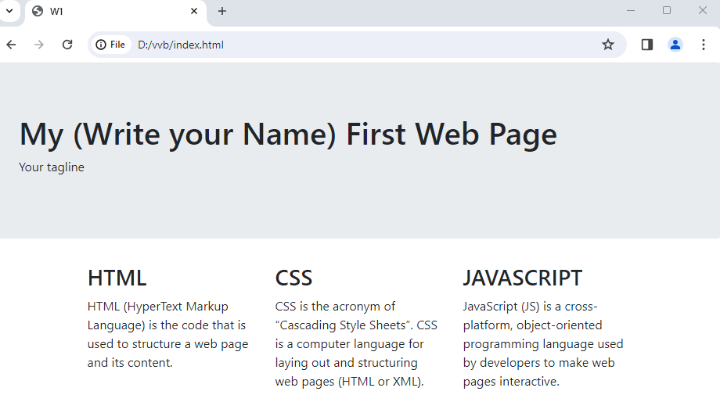

**EXPERIMENT 2:** **Write CSS5 & HTML5 Code to show Dropdown Menu.**

**SOURCE CODE:**

<!DOCTYPE html>

<html lang="en">

<head>

<meta charset="UTF-8">

<meta name="viewport" content="width=device-width, initial-scale=1.0">

<title>Bootstrap Navbar with Dropdown Example</title>

<link href="https://cdn.jsdelivr.net/npm/bootstrap@5.3.0-alpha1/dist/css/bootstrap.min.css" rel="stylesheet">

<link rel="stylesheet" href="https://cdn.jsdelivr.net/npm/bootstrap-icons@1.10.3/font/bootstrap-icons.css">

<script src="https://cdn.jsdelivr.net/npm/@popperjs/core@2.11.6/dist/umd/popper.min.js"></script>

<script src="https://cdn.jsdelivr.net/npm/bootstrap@5.3.0-alpha1/dist/js/bootstrap.min.js"></script>

</head>

<body>

<nav class="navbar navbar-expand-lg navbar-dark bg-dark">

<div class="container-fluid">

<a class="navbar-brand" href="#">Navbar</a>

<button class="navbar-toggler" type="button" data-bs-toggle="collapse" data-bs-target="#navbarNav" >

<span class="navbar-toggler-icon"></span>

</button>

<div class="collapse navbar-collapse" id="navbarNav">

<ul class="navbar-nav">

<li class="nav-item">

<a class="nav-link active" href="#">Home</a>

</li>

<li class="nav-item ">

<a class="nav-link active" href="#">Features</a>

</li>

<li class="nav-item dropdown ">

<a class="nav-link active dropdown-toggle" href="#" id="navbarDropdown" role="button" data-bs-toggle="dropdown" aria-expanded="false">

Dropdown

</a>

<ul class="dropdown-menu" aria-labelledby="navbarDropdown">

<li><a class="dropdown-item" href="#">Action</a></li>

<li><a class="dropdown-item" href="#">Another action</a></li>

<li><hr class="dropdown-divider"></li>

<li><a class="dropdown-item" href="#">Something else here</a></li>

</ul>

</li>

</ul>

</div>

<div class="nav navbar-nav ">

<a href="#" class="btn btn-secondary btn-lg"><i class="bi bi-search">Search</i></a>

<a href="#" class="btn btn-secondary btn-lg"><i class="bi bi-person-circle">User</i></a>

</div>

</div>

</nav>

</body>

</html>

**OUTPUT:**

**-**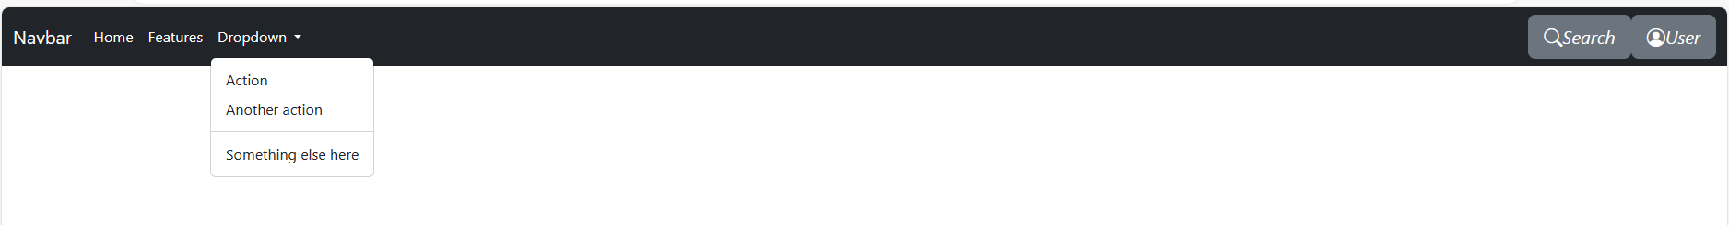

**EXPERIMENT 3: Design Single Page Application with different menu items.**

**SOURCE CODE:**

* + - npm install -g @angular/cli
    - ng new my-app
    - cd my-app
    - ng serve –open

Opens your browser to http://localhost:4200/

# **app.component.html**

<app-navbar></app-navbar>

<router-outlet></router-outlet>

# **home.component.html**

<p>home works!</p>

<h1>Lorem ipsum, dolor sit amet consectetur adipisicing elit. Rerum, ad? Neque ducimus repellendus enim veniam vel magnam perspiciatis fugit nesciunt?</h1>

<h2>Lorem ipsum dolor sit amet consectetur adipisicing elit. In, aperiam.</h2>

# **about.component.html**

<h1>about works!</h1>

<p>Lorem ipsum dolor sit, amet consectetur adipisicing elit. Consectetur ab natus aperiam, saepe accusantium voluptas dolo</p>

# **app-routing.module.ts**

const routes: Routes = [

{ path: 'Home', component: HomeComponent },

{ path: 'About', component: AboutComponent },

];

**OUTPUT:**



**EXPERIMENT 4:** **Write a program in CSS to show your city with building and moving cars.**

**SOURCE CODE:**

**Index.html**

<!DOCTYPE html>

<html lang="en">

<head>

<meta charset="UTF-8">

<meta http-equiv="X-UA-Compatible" content="IE=edge">

<meta name="viewport" content="width=device-width, initial-scale=1.0">

<title>Moving Cars</title>

<link rel="stylesheet" href="style.css">

</head>

<body>

<div class="container">

<div class="road"></div>

<div class="road-sideview"></div>

<div class="moving-car">

<img src="bmw.png" alt="moving-car">

</div>

<div class="car-wheel">

<img src="wheel.png" alt="moving car wheel" class="car-back-wheel">

<img src="wheel.png" alt="moving car wheel" class="car-front-wheel">

</div>

</div>

</body>

</html>

**style.css**

* {

margin: 0;

padding: 0;

}

.container {

height: 50vh;

width: 100%;

background-image: url(sky1.jpg);

background-size: cover;

background-position: center;

position: relative;

overflow-x: hidden;

}

.road {

height: 200px;

width: 300%;

display: block;

background-image: url(road.jpg);

position: absolute;

bottom: 0;

left: 0;

right: 0;

z-index: 1;

background-repeat: repeat-x;

animation: road 5s linear infinite;

}

@keyframes road {

100% {

transform: translateX(-3400px)

}

}

.road-sideview {

height: 130px;

width: 1000%;

background-image: url(city.png);

position: absolute;

bottom: 200px;

left: 0;

right: 0;

display: block;

z-index: 1;

background-repeat: repeat-x;

animation: road-sideview 5s linear infinite;

}

@keyframes road-sideview {

100% {

transform: translateX(-1400px);

}

}

.moving-car {

width: 500px;

left: 50%;

bottom: 50px;

transform: translateX(-50%);

position: absolute;

z-index: 2;

}

.moving-car img {

width: 90%;

animation: moving-car 1s linear infinite;

}

@keyframes moving-car {

100% {

transform: translateY(-1px);

}

50% {

transform: translateY(1px);

}

0% {

transform: translateY(-1px);

}

}

.car-wheel {

left: 50%;

bottom: 198px;

transform: translateX(-50%);

position: absolute;

z-index: 2;

}

.car-wheel img {

width: 65px;

height: 65px;

animation: car-wheel .5s linear infinite;

}

@keyframes car-wheel {

100% {

transform: rotate(360deg);

}

}

.car-back-wheel {

left: -170px;

position: absolute;

}

.car-front-wheel {

left: 80px;

position: absolute;

}

**OUTPUT:**



**EXPERIMENT** 5: **Write a program to validate web form using JavaScript.**

**Source Code:**

**Validation.html**

<!DOCTYPE html>

<html>

<head>

<meta http-equiv="Content-Type" content="text/html; charset=UTF-8">

<title>Register</title>

<style>

body {

text-align: center;

font-family: sans-serif;

}

h1 {

font-size: 20px;

}

table tr td {

padding-top: 6px;

padding-bottom: 6px;

}

fieldset {

width: 500px;

text-align: center

}

</style>

<script>

function validate() {

var fn = frm.fname.value;

for (x in fn) {

ch = fn.charCodeAt(x);

if (ch < 65 || ch > 90 && ch < 97 || ch > 122) {

alert("Invalid firstname");

return false;

}

}

var ln = frm.lname.value;

for (y in ln) {

ch = ln.charCodeAt(y);

if (ch < 65 || ch > 90 && ch < 97 || ch > 122) {

alert("Invalid lastname");

return false;

}

}

var phn = frm.phone.value;

var lenp = phn.length;

if (lenp !== 10) {

alert("Phone no should be exactly 10 digits");

return false;

}

var pwd1 = frm.pwd.value;

var pwdl = pwd1.length;

if (pwdl % 2 === 1) {

alert("Password should contain even number of characters");

return false;

}

if (pwdl > 8) {

alert("Password should not exceed 8 digits");

return false;

}

var reg = /^\w+([-+.']\w+)*@\w+([-.]\w+)*\.\w+([-.]\w+)*$/;

var mail = frm.mailid.value;

if (reg.test(mail)) {

alert("Valid email");

}

else {

alert("Invalid email");

return false;

}

return true;

}

</script>

<body>

<div id="container"></div>

<div id="header">

<h1>Registration</h1>

</div>

<div id="content">

<center>

<form name="frm" method="POST" action="success.html" onSubmit="return validate()">

<fieldset align="center">

<table align="center">

<tr>

<td>First Name: </td>

<td><input type="text" name="fname" value="" size="50" required /></td>

</tr>

<tr>

<td>Last Name: </td>

<td> <input type="text" name="lname" value="" size="50" required /></td>

</tr>

<tr>

<td>Phone No: </td>

<td> <input type="text" name="phone" value="" size="50" required /></td>

</tr>

<tr>

<td>Mail id:</td>

<td><input type="email" name="mailid" value="" size="50" required /></td>

</tr>

<tr>

<td>Gender:</td>

<td>Male: <input type="radio" name="gender" value="male">

Female: <input type="radio" name="gender" value="female"></td>

</tr>

<tr>

<td>DOB :</td>

<td><input type="date" name="dob" size="50" required /></td>

</tr>

<tr>

<td>Username:</td>

<td><input type="text" name="uname" value="" size="50" required /></td>

</tr>

<tr>

<td>Password:</td>

<td><input type="password" name="pwd" value="" size="50" required /></td>

</tr>

<tr>

<td>Age:</td>

<td><input type="text" name="age" value="" size="50" required /></td>

</tr>

</table>

<input type="submit" value="SUBMIT" name="submit" />

</fieldset>

</form>

</div>

</center>

</body>

<div id="footer">

Copyright © CMRIT_2023to2024

</div>

</div>

</html>

**Success.html**

<!DOCTYPE html>

<html>

<body>

<h1>Registration completed</h1>

</body>

</html>

**Output:**

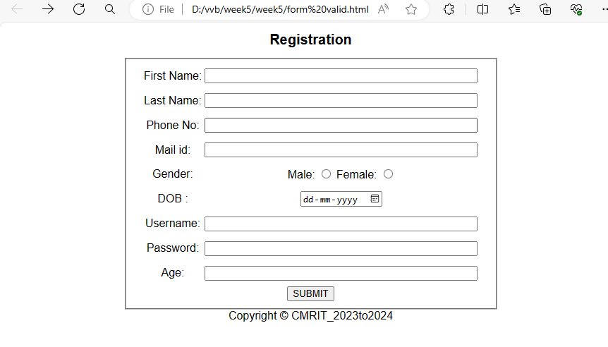

**EXPERIMENT 6: Write jquery code to show website slider.**

**Source Code**

**Corousel.html:**

<!DOCTYPE html>

<html lang="en">

<head>

<meta charset="UTF-8">

<meta http-equiv="X-UA-Compatible" content="IE=edge">

<meta name="viewport" content="width=device-width, initial-scale=1.0">

<title>JS Slider</title>

<link rel="stylesheet" href="https://maxcdn.bootstrapcdn.com/bootstrap/3.4.1/css/bootstrap.min.css">

<script src="https://ajax.googleapis.com/ajax/libs/jquery/3.5.1/jquery.min.js"></script>

<script src="https://maxcdn.bootstrapcdn.com/bootstrap/3.4.1/js/bootstrap.min.js"></script>

</head>

<body>

<div class="container">

<div id="myCarousel" class="carousel slide">

<ol class="carousel-indicators">

<!--The carousel-indicators list provides small circles or dots at the bottom of the carousel to indicate the currently active slide-->

<li class="item1 active"></li>

<li class="item2"></li>

<li class="item3"></li>

</ol>

<div class="carousel-inner" role="listbox">

<div class="item active">

<img src="5.jpg" alt="image1" width="50%" height="50%">

</div>

<div class="item">

<img src="6.jpg" alt="image2" width="100%" height="100%">

</div>

<div class="item">

<img src="7.jpg" alt="image3" width="100%" height="100%">

</div>

</div>

<a class="left carousel-control" href="#myCarousel" role="button">

<span class="glyphicon glyphicon-chevron-left" aria-

hidden="true"></span>

<span class="sr-only">Prev</span>

</a>

<a class="right carousel-control" href="#myCarousel" role="button">

<span class="glyphicon glyphicon-chevron-right" aria-

hidden="true"></span>

<span class="sr-only">Next</span>

</a>

</div>

</div>

<script>

$(document).ready(function(){

$("#myCarousel").carousel();

$(".item1").click(function(){

$("#myCarousel").carousel(0);

})

$(".item2").click(function(){

$("#myCarousel").carousel(1);

})

$(".item3").click(function(){

$("#myCarousel").carousel(2);

})

$(".left").click(function(){

$("#myCarousel").carousel("prev");

})

$(".right").click(function(){

$("#myCarousel").carousel("next");

})});

</script>

</body>

</html>

**OUTPUT:**

# 

**EXPERIMENT 7: Write a program in javascript to create a user login system.**

**Source Code:**

**Login.pug:**

doctypehtml

html(lang="en")

head

meta(charset="UTF-8")

meta(http-equiv="X-UA-Compatible", content="IE=edge")

meta(name="viewport", content="width=device-width, initial-scale=1.0")

title Login

style

include ./my.css

body

div(class='container')

include ./index.pug

h1 Login form

br

form(action="/Login" method="post" align="center")

label(for="username") username

input(type="text" name="username")

br

br

label(for="password") password

input(type="password" name="password")

br

br

input(type="submit" name="Login" value="Login")

**Style.css**

              h1{

color:blue;

text-align:center;

}

a:link,a:visited{

background-color: brown;

color:white;

padding:14px 25px;

text-align: center;

display: inline-block;

}

a:hover,a:active{

background-color: chartreuse;

}

.header {

padding: 10px;

text-align: center;

background: #1abc9c;

color: white;

font-size: 30px;

}

.container {

border-radius: 5px;

background-color: #f2f2f2;

padding: 10px;

}

input{

width: 20%;

padding: 12px;

border: 1px solid #ccc;

margin-top: 6px;

margin-bottom: 16px;

resize: vertical;

}

input[type=submit] {

background-color: #04AA6D;

color: white;

padding: 12px 20px;

border: none;

cursor: pointer;

}

input[type=submit]:hover {

background-color: #45a049;

}

label{

color: blue;

font-size: 22px;

padding: 8px;

text-align:left;

}

**App.js**

Const  express=require('express');

const bodyparser=require("body-parser")

const bcrypt=require("bcrypt");

const user=require('./models/user');

const mongoose = require('mongoose');

const expressValidator = require("express-validator");

const {check, validationResult} = require('express-validator/check')

const app = express();

const port = process.env.PORT || 80

mongoose.connect("mongodb://localhost:27017/user",{userNewUrlP

arser : true});

app.set('view engine', 'pug');

app.use(bodyparser.json());

app.use(bodyparser.urlencoded({extended:true}));

//handling get request

app.get('/',function(req,res){

res.render('index')

})

app.get('/Login',function(req,res){

res.render('Login')

})

//handling post request

app.post('/Login',function(req,res){

user.findOne({username:req.body.username},function(err,docs){

if(err)

{

console.log(err)

}

else

{

if(docs.username==req.body.username)

{

bcrypt.compare(req.body.password,docs.password,function(err,data)

{

if(err)

{

console.log(err);

}

if(data)

{

console.log(data);

res.send("Welcome");

}

else

{

res.send("invalid password");

}

});

}

else

{

//res.send("invalid username or password")

res.redirect("Register");

}

}

})

})

app.listen(port,() => {console.log(`app is listening on http://localhost:${port}`)})

  Models/user.js

 const  mongoose=require('mongoose');

  const Schema=mongoose.Schema;

const userSchema=new Schema(

{

username : {type:String},

password : {type:String},

age : {type:Number},

mobile : {type:Number}

}

);

module.exports=mongoose.model("user",userSchema);

**OUTPUT:**

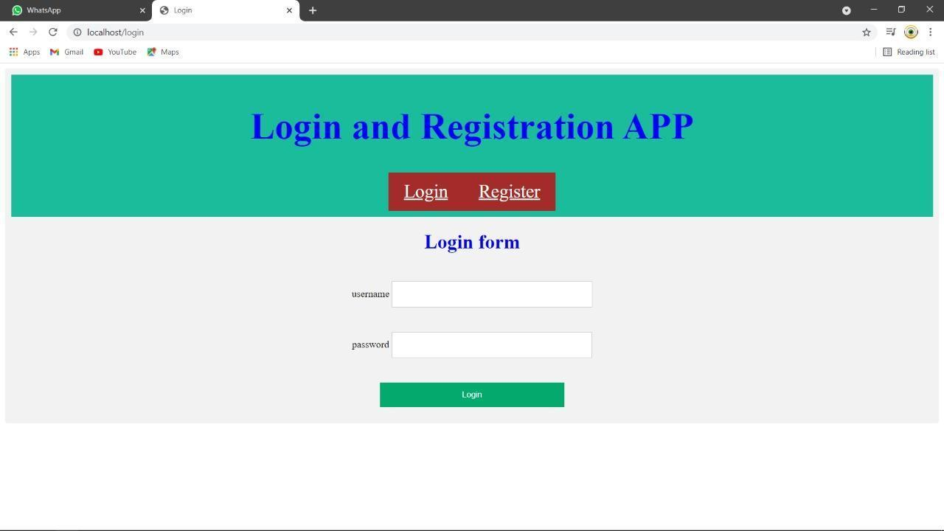

**EXPERIMENT 8: Write a program in javascript to create a user registration system.**

**Source Code:**

**Register.pug**

doctypehtml

html(lang="en")

Head

meta(charset="UTF-8")

meta(http-equiv="X-UA-Compatible", content="IE=edge")

meta(name="viewport", content="width=device-width, initial-scale=1.0")

title Register

style

include ./my.css

body

div(class='container')

include ./index.pug

h1 Registration form

ul(id="errors")

Br

form(action="/Register" method="post" align="center")

label(for="username") username

input(type="text" name="username")

Br

Br

label(for="password") password

input(type="password" name="password")

Br

label(for="cpassword") Confirm password

input(type="password" name="cpassword")

Br

Br

label(for="age") user age

input(type="text" name="age")

Br

Br

label(for="mobile") user mobile

input(type="text" name="mobile")

Br

                label(for="email") user email

              input(type="text" name="email")

                  Br

                Br

input(type="submit" name="Register" value="Register")

**App.js**

Const express=require('express’);

const bodyparser=require("body-parser") const bcrypt=require("bcrypt");

const user=require('./models/user'); const mongoose = require('mongoose');

const expressValidator = require("express-validator");

const {check, validationResult} = require('express-validator/check') const app = express();

Const port = process.env.PORT || 80 mongoose.connect("mongodb://localhost:27017/user",{userNewUrlParser : true}); app.set('view engine', 'pug')

app.use(bodyparser.json()); app.use(bodyparser.urlencoded({extended:true}));

//handling get request app.get('/',function(req,res){ res.render('index')

})

app.get('/Register', function(req, res){

res.render('Register')

})

//handling post request

app.post('/Register', [

check('username').not().isEmpty().isLength({min:5}).withMessage('User name must be 5 characters'), check('password').not().isEmpty().isLength({min:6}).withMessage('Password name must be 6

characters'),

check('mobile').not().isEmpty().isInt().isLength({min:10}).withMessage('mobile number must be

number and 10 characters'),

check('cpassword').custom((value,{req}) => (value === req.body.password)).withMessage("Confirm password not match with your password"),

check('email').not().isEmpty().isEmail().normalizeEmail().withMessage("Enetr proper email"),

],

function(req,res){

const errors= validationResult(req);

 if(!errors.isEmpty())

{

return res.status(422).jsonp(errors.array());

}

else{

//console.log(req.body.username)

const newUser=new user();

newUser.username=req.body.username;

var salt=bcrypt.genSaltSync(10);

varhash=bcrypt.hashSync(req.body.password,salt);

newUser.password=hash;

newUser.age=req.body.age;

 newUser.mobile=req.body.mobile;

 newUser.save(function(err,result){

if(err){

console.log(err);

}

else{

console.log(result);

res.redirect("Login");

}

})

}

})

})

app. listen(port,() => {console.log(`app is listening on http://localhost:${port}`)})

**Model/users.js**

Const mongoose=require('mongoose');

const Schema=mongoose. Schema;

const user Schema=new Schema(

{

username : {type: String},

password : {type: String},

age : {type: Number},

mobile : {type: Number}

}

);

module.exports=mongoose. model("user",userSchema);

**OUTPUT:**

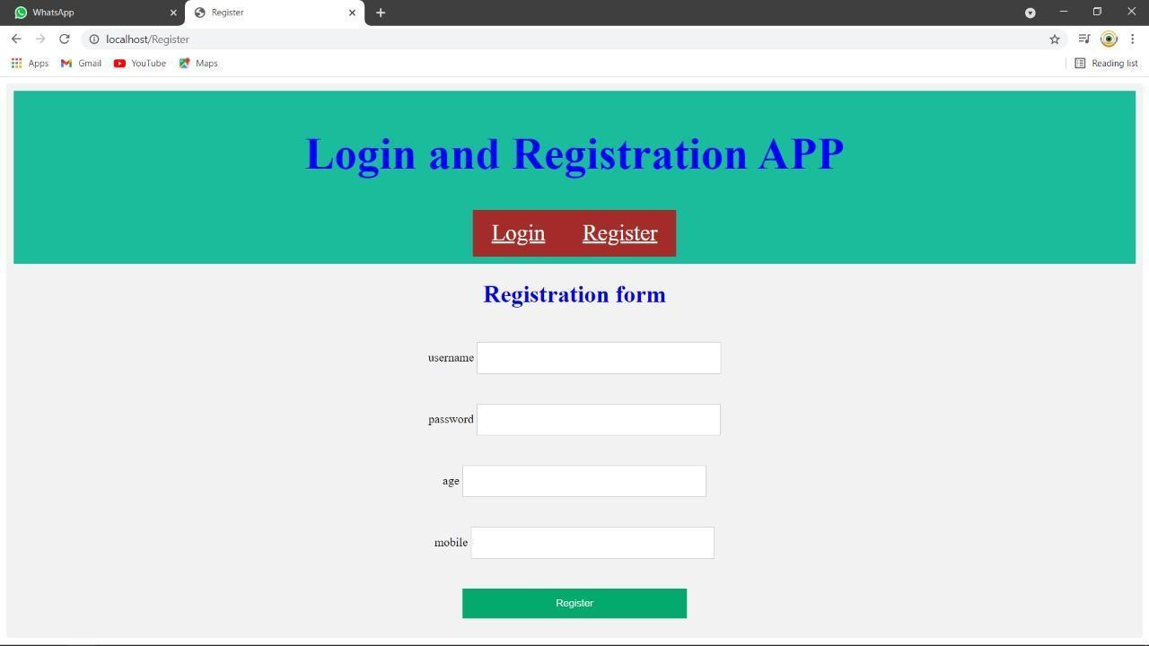

**EXPERIMENT 9: Write a program to display user details using HTML, CSS &AJAX.**

**Source Code:**

**Ajax.pug:**

 doctype html

html(lang"en")

       head

       meta(charset="UTF-8")

meta(http-equiv="X-UA-compatible",content="IE=edge")

meta(name="viewport",content="width=device-width,initial-scale=1.0")

 title Login

style

include./my.css

script(src="<http://code.jquery.com/jquery-3.1.0.min.js>") script(src="/magic.js")

include ./index.pug

body

div(class='container')

form(method="post" id="change" align="center") input(type='text', placeholder='search user', name='name') input(type="submit", value="Search")

br

h1 User Details p !{name}

**/public/magic.js**

$(document).ready(function(){

  $("form#change").on('submit',function(e)

{

e.preventDefault();

var data = $('input[name=name]').val();

$.ajax({

type: 'post',

url: '/ajax',

data:data,

dataType: 'text'

})

.done(function(data){

$('h1').html(data.name);

});

});

});

**App.js**

const express = require('express');

const bodyparser=require("body-parser")

const bcrypt=require("bcrypt");

const user=require('./models/user');

const mongoose=require('mongoose');

const expressValidator = require("express-validator");

const {check, validationResult} = require('express-validator/check')

const app = express();

const port = process.env.PORT || 80

mongoose.connect("mongodb://localhost:27017/user",{userNewUrlParser : true}); app.set('view engine', 'pug');

app.use(bodyparser.json());                                  app.use(bodyparser.urlencoded({extended:true});

app.get('/ajax', function(req, res){

res.render('ajax', {title: 'An Ajax Search', name: "Search user!"});

});

app.post('/ajax', function(req, res){

user.findOne({username:req.body.name},function(err,docs)

{

if(err)

{

console.log(err)

}

else

{

res.render('ajax', {title: 'An Ajax search', name: "Name "+docs.username+", Age "+docs.age+", Mobile "+docs.mobile });

}

});

});

app.listen(port,() => {console.log(`app is listening on http://localhost:${port}`)})

**OUTPUT:**

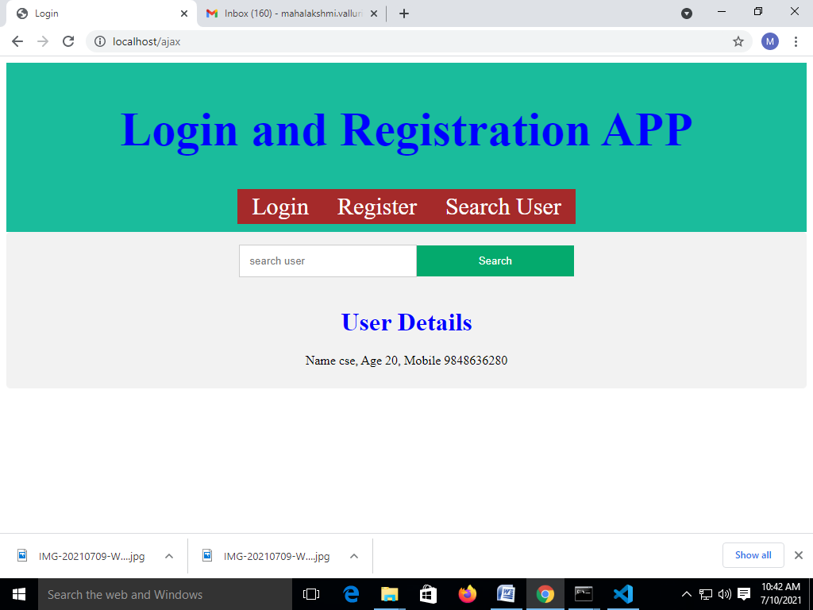

**EXPERIMENT 10: Demonstrate version control in Git and Github.**

Source Code:

$ git config --global user.name "cmr"

$ git config --global user.email [cmr@example.com](mailto:cmr@example.com)

Index.html

<h1>welcome to my web page</h1>

git init git add .

git commit -m "Hello world"

Index.html

<h1>welcome to my web page</h1>

<p>My first website</p>

git add .

git commit -m "paragraph added"

git log git staus

git branch -M main

git remote add origin url

git push –u origin main

**OUTPUT:**

